Micro Hydro Lab
Strongly adapted from HSU Engr305 students Ayers-Williams, Kuoppamaki, Wu 2005, and micro hydro expert Don Harris 2007.

The objectives of this lab include the following:

- Measure your personal stride
- Become familiar with and accurately measure flow
- Become familiar with a tape measure and level
- Become familiar with and adequately measure head
- Perform calculations with stride, flow, head, and power

The following equipment/materials are required to complete this lab:

Qty. | Equipment/Material | Purpose/Use
3 | People (total minimum). Select roles A, B, and C. If there is a large group, two or more people can function as one role. | Measure, read, and record data.
1 | Pencil | Record data
1 | Note pad | Record data
1 | Calculator | Calculate data
1 | Tape measure. 30-feet minimum. | Measure length for stride
1 | Stop watch | Measure time
1 | 5-gallon bucket | Measure volume of water
1 | Measuring stick, (straight stick, beam, or pole, just under 5 feet in length). | Measure height.
1 | I-Beam spirit Level, (15" to 24" is convenient). This kind of level usually looks like a metal bar around 2" to 3" wide. | Keep height measurements accurate. Sits on top of measuring device to bring total measuring height to 5 feet.
1 | Moving water source with access to a place in which the water can be captured in a bucket. | Measure flow.
1 | Planar (flat) inclined walking surface parallel to and preferably near the moving water source. | Measure stride.

Chart 1. Equipment/Materials List

Measuring Flow

Flow is a volume of water which is displaced in a specified amount of time. Flow is a rate.
Figure 1: Model of water flow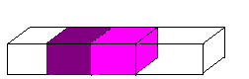
Water Flow

Figure 1 is a simplified version of flow. In the image there is water flowing through a box. In an instant of time, there is a certain volume of water in the dark purple box. After a certain amount of time, all of the water in the purple box will have flowed into the light purple box. The volume of the box (both boxes have equal volume) divided by the time it took to move all the water from the dark purple box to the light purple box is the amount flow of the water.

There are several methods of measuring flow. Which method you use depends on the situation in which you encounter. For measuring the flow in a small creek, the “bucket method” will probably be the best. It is a fairly accurate and simple method.

To measure flow the following items are needed:
- A bucket of known volume, for example a 5-gallon bucket
- A timer
- Falling water which can be completely captured in the bucket
- Notebook and Pencil

The measurement is easiest with three people. Member A fills the bucket with water, Member B times the operation and Member C records the measurements.

The following steps are performed in the field:

First find a site that is easy and SAFE to measure. Also make sure that this site has very similar flow to the site that you will measure head at. Look for tributaries and inlets between the site you measure flow and the site that you measure head.

- Member A places the bucket in front (Figure 2) of the waterfall prepared to put the bucket underneath the waterfall.
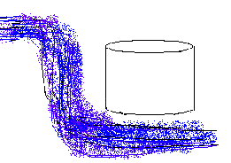
Figure 2: Prepared bucket

- Member B says “Go,” and starts the timer.
- Member A places the bucket underneath the waterfall. It is essential that all of the water be captured in the bucket while it is under the waterfall. (Figure 3)

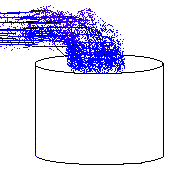
Figure 3: Water filling bucket
- When the bucket is full, the Member A says, “Stop”.
- Member B stops the timer and announces the time it took to fill the bucket.
- Member C writes down how many seconds it took to fill the bucket.
- Empty the bucket and repeat this procedure at least three times. The more times the better.
- It is important before any lab that a list of reasons to throw out data points is determined. Here are some reasons why one might not want to accept certain data:
  - The bucket is not capturing all of the water.
  - The bucket overflows before the bucket holder says stop.
  - Other obvious errors by the timer or the bucket holder.
  - A large piece of debris falls down the waterfall into the bucket.

Calculations
To determine the flowrate of the water, all one needs to know is the volume of the bucket and the times it took to fill it.

The first step is to find the average of all of the times recorded for filling the bucket. The equation for this is as follows:

Average Time = 1st time + 2nd time + 3rd time ............
Total number of time measurements

The second step is to calculate the flow rate (Q). The units of flowrate are in unit volume per unit time.

Q = Volume of bucket
Average time

Example:
Say five times are measured:
2.5 seconds, 2.7 seconds, 2.0 seconds, 2.5 seconds, 2.6 seconds

The equation would look like this:

Average time = 2.5s+2.7s+2.0s+2.5s+2.6s = 2.5s
5

The volume of the bucket, 5 gallons, is known, as well as the time, 2.5 seconds.

Q = 5 gallons = 2 gallons/second
2.5 seconds

Often, flow is given in gallons per minute or liters per second. To obtain these units, perform the following unit conversions.

2 gallons x 60 seconds = 120 gallons aka GPM
second minute minute

120 gallons x 3.8 liters = 465 liters aka lps
minute gallon second

Alternate Method: Float

Another way to measure flow is to use the float method. Calculate the width and average depth of a cross sectional area of the water flow as shown in Figure 4.
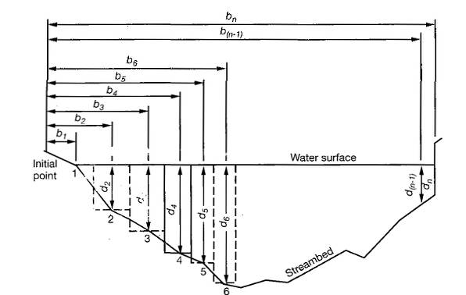
Figure 4: Measuring cross sectional area from average depth and width. Image credit: Don Harris

Then measure a length of the river and drop a floater to measure the velocity of the river as shown in Figure 5.
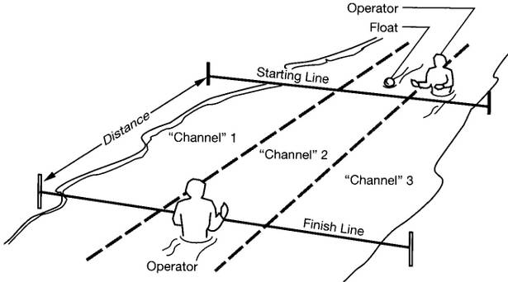
Figure 5: Measuring stream velocity using float method. Image credit: Don Harris
Then multiply the cross sectional area by the velocity to get the volumetric flow.

Measuring Length of Stride

To measure the length of stride the following items are needed:
- Tape measure at least 30-feet long
- Pencil, notepad, calculator
- Planar (flat) inclined walking surface

- Lay out tape measure to, at minimum, 30-feet on the ground of a straight-flat inclined walking surface as seen in Figure 6.

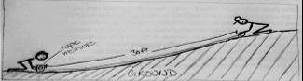
Figure 6: Measuring ground.

- Stand next to the beginning of the tape measure and count the number of individual steps it takes to get to the other end of the tape measure (____-feet away) as shown in Figure 7. Walk normally, taking care not to stretch out steps or to shorten them.

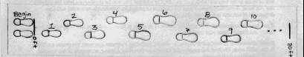
Figure 7: Counting steps.
- Record your name and how many steps you took as shown in Table 1.
Table 1: Stride Data
Name_____________________ | Uphill | Downhill
1st run - #steps:
2nd run - #steps:
3rd run - #steps:
Average #steps:
divided into ____ ft:
Average stride:

- Repeat process downhill, begin at the end of the tape measure, and count the number of steps it takes to get to the other end and record data.
Note: it is common that less steps are needed while going downhill, for this reason it is important to count your steps going both up hill and downhill. (Level stride is usually in between uphill and downhill stride)

- Repeat the process two more times
- Add the three uphill step entries together and divide by 3 to get the average. Do the same for the downhill entries.
- Now divide _____ft by your step average to get the length of your stride

Measuring Head

Head is the difference between two points of elevation in a body of fluid [Merriam-Webster, 2005]. For the purposes of this lab, head is a difference in the height of water at two spots along a moving water source.

To measure head you will need the following:
- Three people (minimum)
- Notebook, pencil, calculator
- Stick for measuring
- Spirit Level 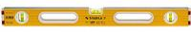
- Planar inclined walkable surface near moving water source

Begin by preparing the equipment. Become familiar with the functions of the level.

The stick for measuring needs to be cut so that when the level sits on top of the measuring stick their combined height equals five feet.

Find an area of significant slope parallel to the flow of water. Start at the lower point of elevation. This low site is called the output, outtake or destination. The highest part of the system, where water will enter pipes toward a turbine, is called the input, intake or the source.

Group member A will firmly place one end of the measuring stick on the ground with the level on top, truing the level and stick setup to the earth. It will be member A's responsibility to keep this setup level for the duration of the first measurement of head.

Group member B will sight down the length of the level in the direction of the highest part of the system. The specific location member B sights indicates a five foot rise in elevation.

Group member C will start walking from next to the level and stick, and will count their steps until member B yells to stop.

Group member B yells to stop when it appears to member B that member C is smaller and standing directly on the level. The site member C is now standing at is five feet higher in elevation than where the level and stick are. Member C records the number of steps it took to get to this site. Now have members A and B move to where member C is standing and repeat the process to measuring the next five feet of elevation difference. The next site where member C stops indicates ten feet of elevation difference. Repeat this process until at least 15 feet of head is obtained or until the slope decreases significantly, recording the number of steps each time. The place where head is last measured will be the highest point of elevation for the system, the source. The number of steps is important in determining how many feet of pipe will be needed for the system. The total walking distance between the source and destination is called the run.

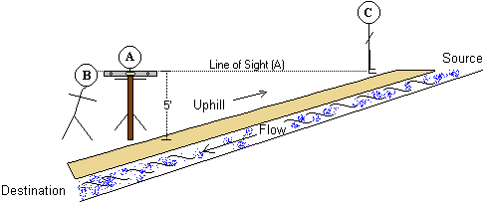
Figure 8: Measuring head.

Return to the initial site. Measure head once again, this time switching roles. Repeat measuring head until everyone has completed the role of member C. Then compile and average your results. Keep in mind that it is important to have criteria with which to throw out results independent of the value, i.e. do not throw out a value just because it seems wrong, have criteria such as – If the walker trips, we will redo that measurement.

It's important to note that due to terrain features, measuring head may prove challenging. Be sure to check that the path used to measure head is level with the water flow. Many trails can increase greatly in elevation while the elevation of the water source remains about the same. Also, be aware of the potential for extra distance gained by terrain features as climbing over logs or rocks may add on to your run. In addition, please note that when designing an actual system you will probably walk in the riverbed for accuracy. We are not doing that due to the impact of an entire class.
Name / Trial | Stride | # Steps | Run for 5’ Head | Total Run | Total Head
Shail / 1 | 2.5 ft/step | 25 steps | 2.5x25=62.5’ | 62.5’ | 5’
Shail / 1 | 2.5 ft/step | 40 steps | 2.5x40=100’ | 162.5’ | 10’
Shail / 1 | 2.5 ft/step | 40 steps | 2.5x40=100’ | 262.5’ | 15’
Pete / 2 | 3.1 ft/step | 29 steps | 3.1x29=58.9’ | 58.9’ | 5’
Pete / 2 | 3.1 ft/step | 35 steps | 3.1x35=108.5’ | 167.4’ | 10’
Pete / 2 | 3.1 ft/step | 34 steps | 3.1x34=105.4’ | 272.8’ | 15’

