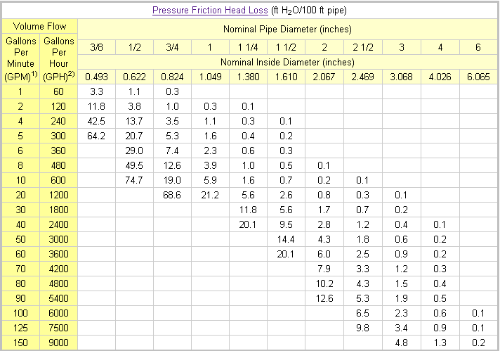
The friction head losses are calculated for PVC pipes Schedule 40 with the Hazen-Williams equation.
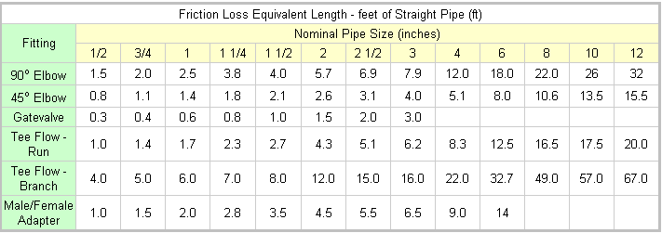

Equation: P=Q*H*e/k , Where P is in kilowatts (kW), H is in feet (ft), e is efficiency and if:

Q is measured in | k is
Ft³ / min | 708 ft⁴/(min*kW)
ft³ / sec | 11.8 ft⁴/(s*kW)
l / sec | 102 l*ft/(s*kW)
GPM | 5310 gal*ft/(min*kW)

